The Remington Volunteer Fire Department in Babcock Wisconsin was started in 1963 by a group of concerned citizens who saw a need for local fire protection.  On October 21, 1975, Remington Township adopted an ordinance that officially recognized the fire department and established it as a part of the town’s infrastructure.  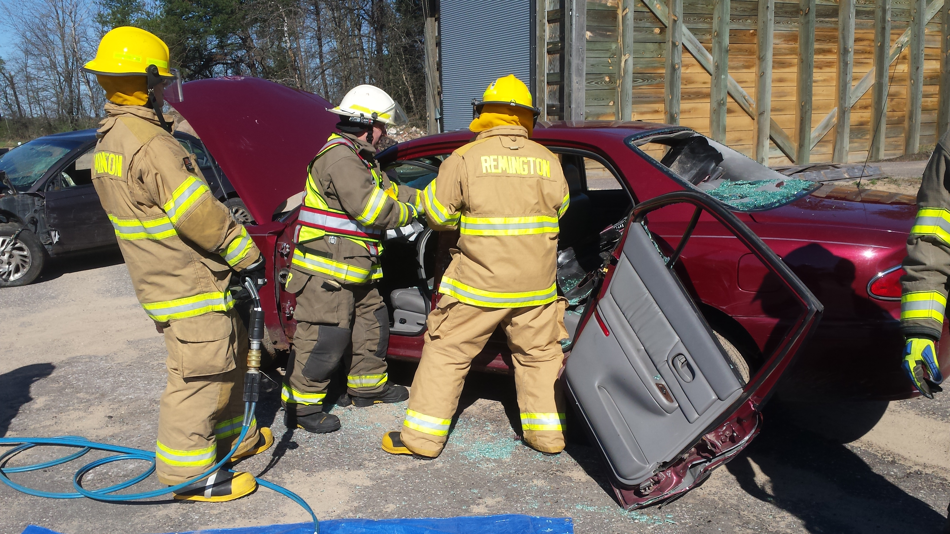 | RVFD  Babcock, Wisconsin | Remington Volunteer Fire Department  P.O. Box 133  Babcock, WI 54413 | Remington  Volunteer  Fire  Department  - COURAGE – HONOR - SACRIFICE

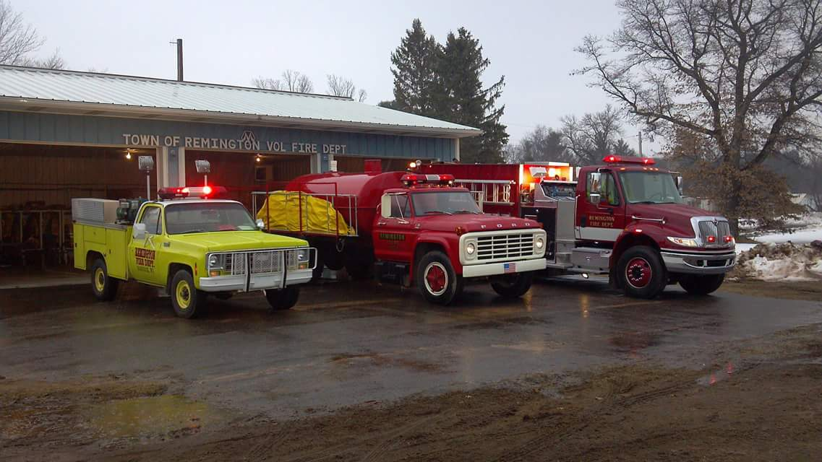  RVFD  RVFD provides fire protection and emergency response services to Remington Township which covers approximately 70 square miles in south west Wood County. We also provide mutual aid assistance to our neighboring fire departments in south west Wood County and north west Juneau County.  Babcock, Wisconsin  Birds, Bogs and Bucks  Babcock is a small rural community in the north east part of Remington Township. Babcock takes pride in its rich history in the cranberry industry and environmental conservation. | Volunteers don’t get paid, not because they are worthless, but because they are  PRICELESS!  RFVD is looking for dedicated individuals who want to:  - Be part of the tradition  - Be part of the excitement  - Be part of the community  - Be a Volunteer Firefighter  For more Information on becoming a part of RVFD  Simply fill out the form on the right and return it in the mail or contact:  Chief Rodney Brockman  715-884-3251  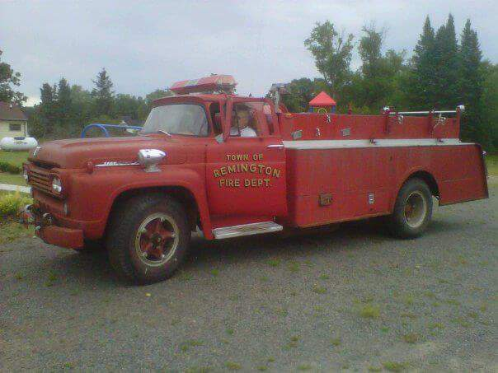 | Fill out and return this form for more information  Name_________________________  Address_______________________  _____________________________  Phone________________________  Age__________________________  Firefighter Training Yes____No____  level______________________  Best time to call________________  Any Questions about RVFD that you would like to have answered_______  _____________________________  _____________________________  _____________________________  Thank you for your interest in the Remington Volunteer Fire Department!  Like us on Facebook at  Remington Volunteer Fire Department

